Midnight Manor: Saving with Claude + Codex
Oct 4, 2026 · @Romello Swinton
Use ChatGPT Plus ($20/mo) for Codex, give Codex the coding and Claude the planning and review, and share context through two small files so neither tool relearns the project.

How to pay
Pay for Codex through ChatGPT Plus ($20/mo), not API credits. Plus includes Codex alongside GPT-5.5, Deep Research and Sora. Through an API key, every file Codex reads and every retry is billed per token, and iterative game coding burns through credits fast.
Full price breakdown: ChatGPT: Subscription vs API Credits.

Who does what
Each tool gets the jobs it's best at, so neither one does double duty and burns through its limits.
Who | Role | Jobs
Codex | Hands-on code in the repo | Writes and edits GameServer.server.luau, GameClient.client.luau and RoundRules.luau; runs node tools/build-place.mjs and the tests
Claude | Thinking and checking | Plans features before Codex writes them, reviews Codex's changes, reads the design notes, debugs from pasted Studio output, writes test cases (head start, 1 killer vs. up to 9 survivors)
Mello | Lead | Decides what gets built next, runs Studio playtests, passes work between the two

The workflow
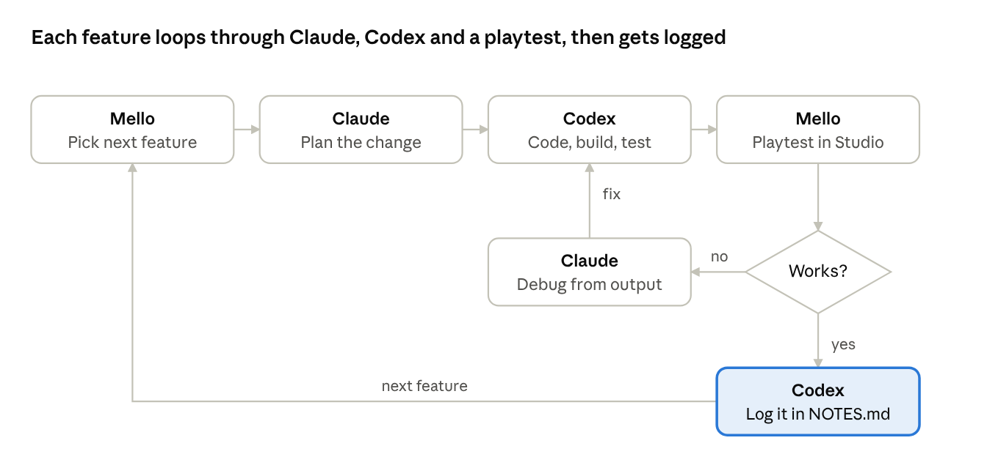
feature loop · 6 steps, 1 decision
A failed playtest goes back to Claude for debugging, then to Codex for the fix. Every finished feature ends with a line in NOTES.md.

Rules that save usage
- Never feed either tool Midnight-Manor.rbxlx. It's about 175 KB of generated XML that the build script rebuilds from src. Point both tools at the .luau files in src and tests only, then rebuild.
- Share context once. AGENTS.md in the project root tells Codex the rules and layout every session automatically. NOTES.md gets one or two lines after each session, so each tool picks up from the notes instead of rediscovering the project.
- Keep requests small and specific. "Fix the head-start timer in RoundRules.luau, here's the error" costs a fraction of "look over my game and fix whatever's wrong."
- Paste only what failed. When tests fail, send the failing lines, not the whole log.
- Work in one copy. The project lives at Desktop\HauntedMansion. Open that folder in Codex, VS Code and Roblox Studio, and delete the old copies.

When to upgrade
Stay on Plus unless Codex keeps cutting you off mid-session. If it does, the $100 Pro tier gives 5x Plus Codex usage. For a solo student project, the rules above should keep you comfortably inside Plus.

Next steps
- ☒ Move the project to Desktop\HauntedMansion
- ☒ Add AGENTS.md, NOTES.md and .gitignore
- ☐ Close Studio, reopen Midnight-Manor.rbxlx from the Desktop folder
- ☐ Delete Documents\Projects\HauntedMansion and the original Codex output copy
- ☐ Start a new Codex session pointed at the Desktop folder
- ☐ Push the project to GitHub so Claude and Codex share one copy
- ☐ Install the pending Windows update so Claude can run builds and tests
- ☐ Run the first multiplayer playtest in Studio

